**Issue 2**: The form title and contents in the form are confusing

**Description**: The form title indicates “ACCOUNT INFORMATION”. However, the below details contains the user’s card details, Address, **which may lead the user’s to think about the authenticity of the site**. Instead of that, it would be good to have two titles- Payment info/Card info and Address.

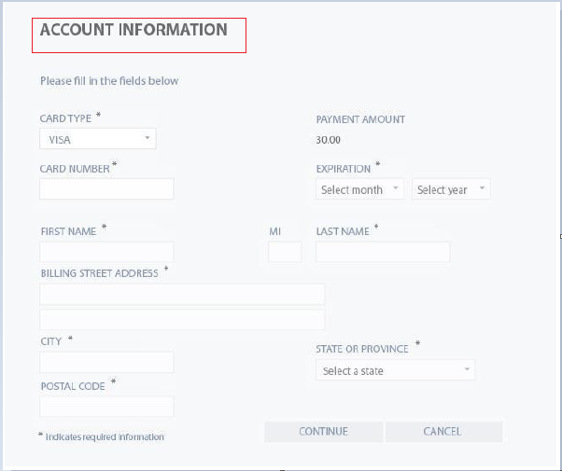

**Expected Behavior**: Form should separate user’s card info and address details

**Severity**: Critical